IOT COLD CHAIN MANAGEMENT SOURCES
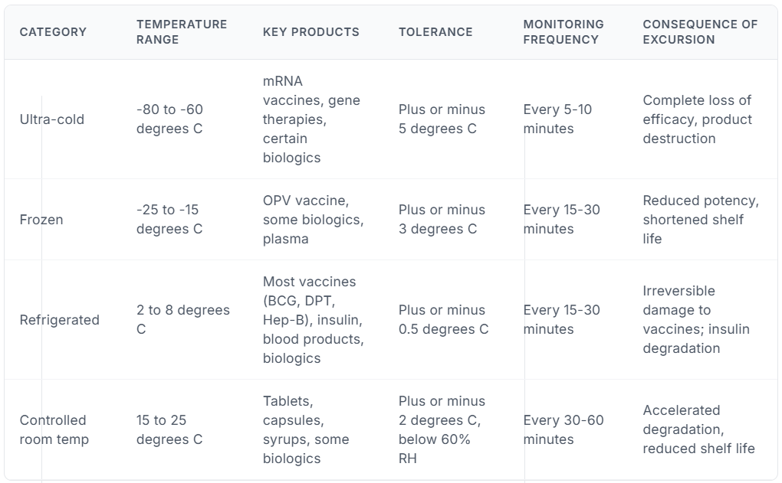
IOT MATE
Cold Chain Monitoring for Pharma & Food: Ensure Compliance and Prevent Crore-Level Losses | IoTMATE Blog
AMBETRONICS
Pharma Cold Chain Monitoring Solution - Ambetronics Engineers
TESSOL
Cold Chain for Pharma – Tessol
GTEK
Vaccine Series Data Loggers | WHO PQS Compliant | G-Tek India
The Equiplog Data Logger | G-Tek Corporation India

